First record of the Tobacco Flea Beetle Epitrix hirtipennis Melsheimer [Coleoptera: Chrysomelidae: Alticinae] in Russia
M. Ja. Orlova-Bienkowskaja
A.N. Severtsov Institute of Ecology and Evolution, Russian Academy of Sciences,
Leninskiy Prospect 33, Moscow, 119071, Russia
Email: marinaorlben@yandex.ru

The invasive pest of tobacco Epitrix hirtipennis (Melsheimer, 1847) is recorded in Russia for the first time. In April 2013 two specimens were collected in Sochi and in May one specimen was collected in Tuapse (near the Black Sea shore, the Northern Caucasus). E. hirtipennis is native to North and Central America. It was firstly recorded from EPPO region in 1983 in Italy. Then it was recorded in Azores (Portugal), Greece, Turkey, Macedonia, Bulgaria, and Syria. E. hirtipennis is the first known alien flea beetle in Russia.

В России обнаружен новый инвазивный вид, вредитель табака – блошка шершавая Epitrix hirtipennis (Melsheimer, 1847). В апреле 2013 года два экземпляра были пойманы в Сочи, а в мае один экземпляр – в Туапсе (Черноморское побережье, Северный Кавказ). E. hirtipennis происходит из Северной и Центральной Америки. Он был впервые отмечен из региона ЕОКЗР в Италии в 1983 г. Затем его обнаружили также на Азорских островах (Португалия), в Греции, Турции, Македонии, Болгарии и Сирии. E. hirtipennis – первая чужеродная блошка (Alticinae), указанная для фауны России.

Flea beetles of the genus Epitrix Foudras 1860 (Coleoptera: Chrysomelidae: Alticinae) are tiny beetles feeding mainly on Solanaceae. Some of them are serious pests. The genus has a worldwide distribution and consists of nearly 180 species. 14 of them are native to Palaearctic, and 12 – to Nearctic (Döberl, 2000). Four Nearctic species have been established in EPPO region: E. cucumeris (Harris, 1851), E. similaris Gentner 1944, E. fasciata Blatchley 1918, and E. hirtipennis (Melsheimer, 1847) (EPPO, 2011). The former two species are included in the list A2 EPPO as serious pests of potato and other vegetables, while the latter two, feeding mainly on tobacco, are not included (EPPO, 2011; Germain et al., 2013).
E. hirtipennis was the first American species of this genus introduced to Europe. In 1983 this species native to North and Central America was found in Europe for the first time in northern Italy (Sannino et al., 1984). Then it quickly spread to South and Central Italy (Sannino & Balbiani, 1990) and was also found in Azores (Portugal) in 1985 (Israelson, 1985), Greece in 1988 (Lykouressis, 1991), Turkey in 1993 (Döberl, 1994), Macedonia in 1996 (Krsteska et al., 2009), Bulgaria in 2000 (Trenchev, Tomov, 2000), and Syria in 2002 (Gruev & Döberl, 2005). Besides that, E. hirtipennis has been introduced to the Pacific region: to Tahiti (Gourves et al., 1979), Fiji (Waterhouse, 1997), and Hawaii (Nishida, 2002). Records from Spain, Sri Lanka, and Philippines (Deseö et al., 1993) are not reliable, because no references on collected material or other details are given. Spread of E. hirtipennis may combine long-distance, human-mediated dispersal and natural dispersal by adult flight (Beenen & Roques 2010).
Larva of E. hirtipennis is root-feeding, while imago feeds on leaves. In the native range E. hirtipennis is known mainly as a pest of tobacco, but can also feed on eggplant, potato, tomato and many other solanaceous plants (Capinera, 2001). In Europe E. hirtipennis causes severe damage on tobacco in Italy, Greece and Bulgaria (Deseö et al., 1993; Lykouressis et al., 1994; Deligeorgidis et al., 2007; Tomov et al., 2007). It also damages eggplant in Greece (Lykouressis, 1991). E. hirtipennis is sometimes found on potato, but is not considered a serious pest of potato crops in the European countries (Boavida & Germain, 2009).
In spring 2013 three specimens of E. hirtipennis were collected by sweeping weeds in the Northern Caucasus near the Black Sea shore [Sochi, Krasnosel'skaya street (43.58°N, 39.76°E), 30.04.2013, 2 females; Tuapse, Kalarasha street (44.13°N, 39.08°E), 7.05.2013, 1 female] (Fig. 1, 2). The specimens will be deposited in the collection of Zoological Institute of Russian Academy of Sciences (St-Petersbourg).

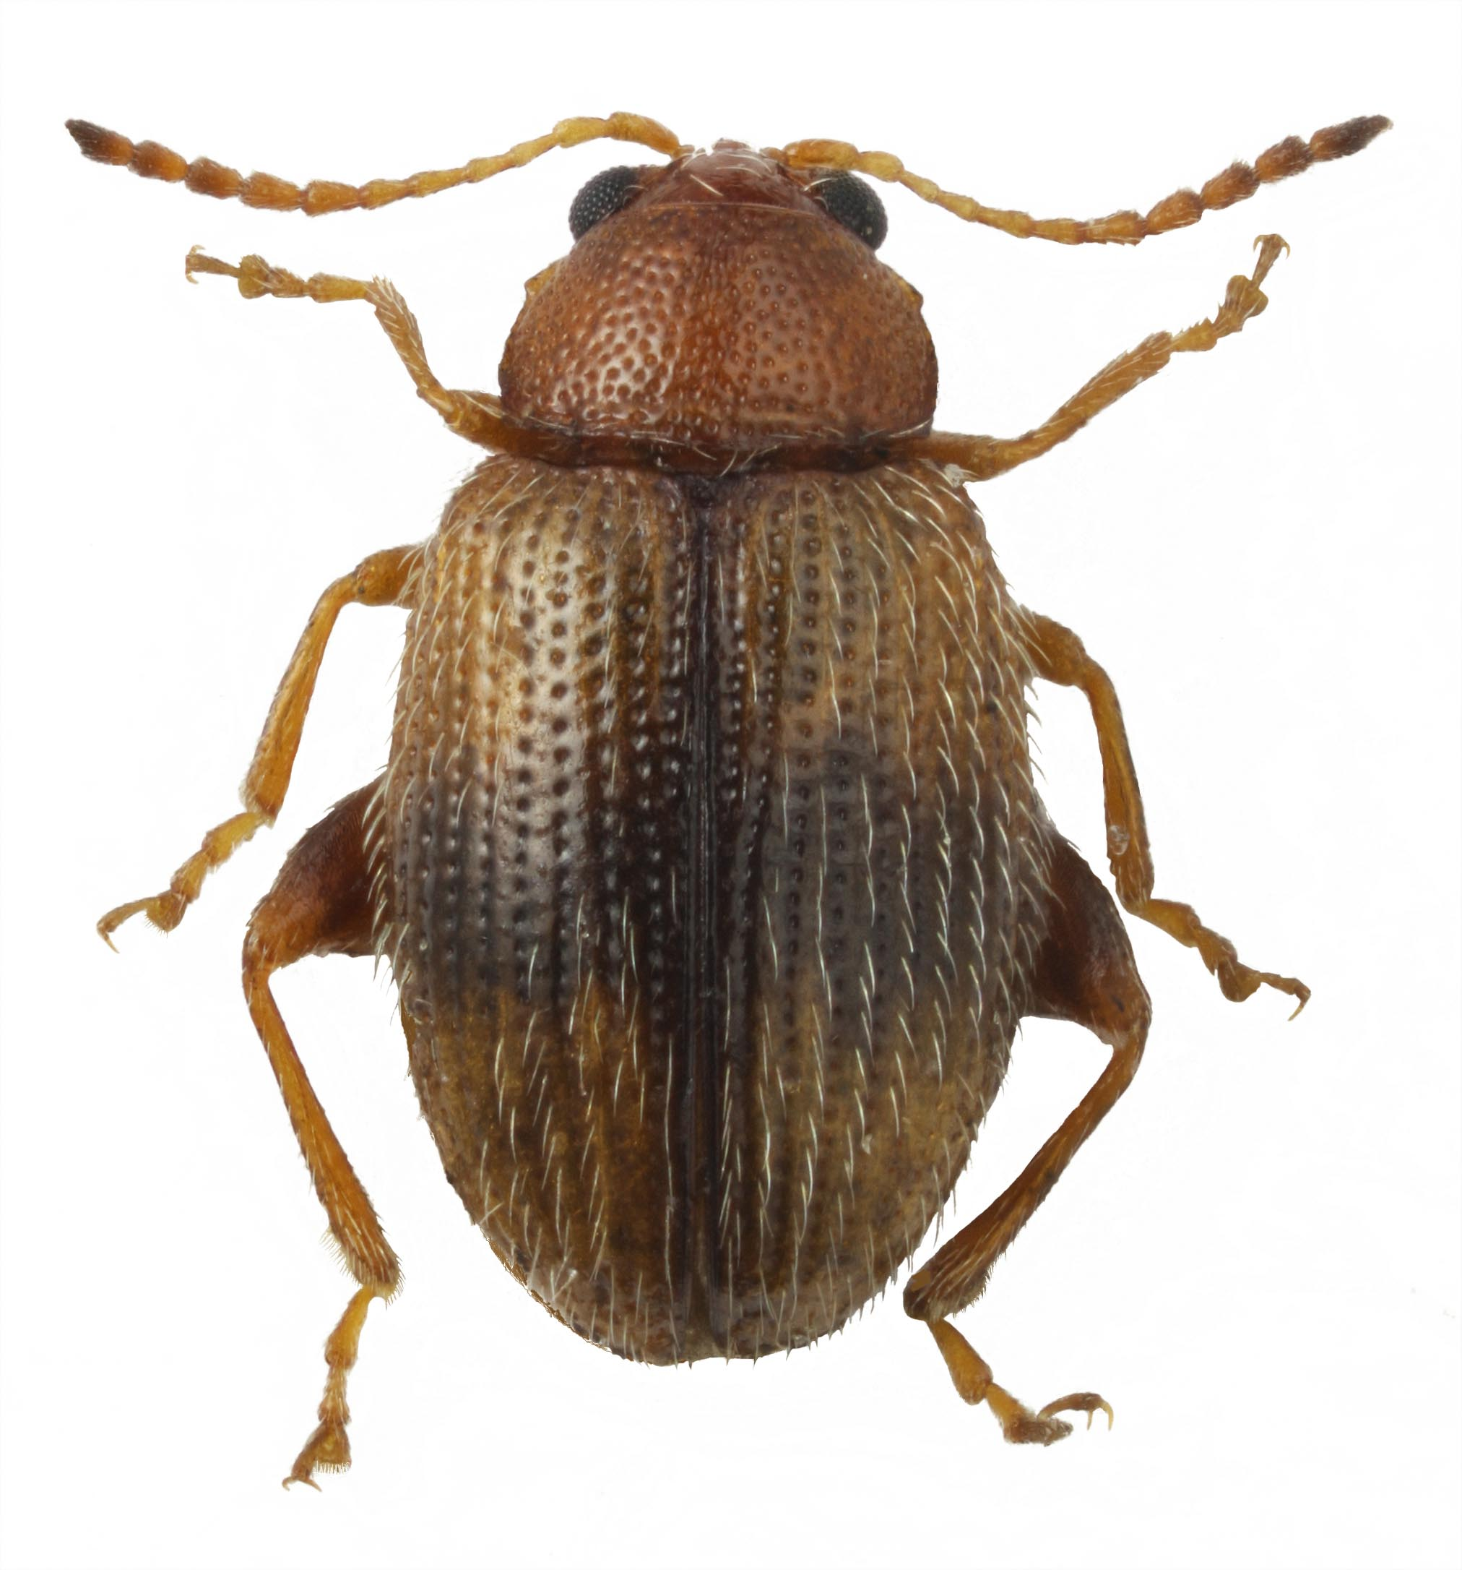
Fig. 1 Female of Epitrix hirtipennis collected in Tuapse (Krasnodar Territory, Russia).

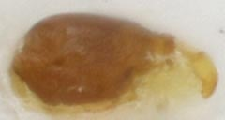

Fig. 2 Spermatheca of the female of Epitrix hirtipennis collected in Tuapse (Krasnodar Territory, Russia).
The specimens have been identified by their external morphology and the structure of spermatheca (White & Barber, 1974; Döberl, 2000). E. hirtipennis differs from the most of Palaearctic and Nearctic Epitrix species in color: head and pronotum are rufous. Pronotal antebasal impression is weak. Elytra are yellow with dark brown suture and transverse stripe at midlength. Elytral intervals are covered with dense long white setae. Thickenings at anterior angles of pronotum are short. Elytral scutellar row of punctures is not reaching to the midlength of elytra and consists of 14 punctures. Pronotum is covered with dense punctures, which are as large as those in elytral rows. Spermatheca is elongate, pear-shaped, without constriction.
E. hirtipennis differs from E. fasciata (American species, introduced to Azores) in the shape of spermatheca, larger and more elongate body (2.05 mm long, 1.9 as long as wide) and in the shape of elytral transverse band, which is not broken at the third interval between puncture rows; from the American species E. subcrinita in the absence of metallic lustre of elytra, in pronotal antebasal impression shallow, and in the shape of spermatheca; from palaearctic E. pubescens ab. ferruginea in the short thickening at anterior angles of pronotum, pronotal antebasal impression shallow, and shorter elytral scutellar row; from E. allardi (endemic of Canary Islands) in short elytral scutellar row; from the far-eastern species E. setosella in yellow elytra and larger pronotal punctures.
Soon after the establishment of E. hirtipennis in Italy its quick expansion to the east was predicted (Döberl, 1994). Now this prognosis is being realized. Only two alien species of leaf-beetles were recorded from Russia until recently: Zygogramma suturalis (Fabricius, 1775), introduced for biological control of ragweed, and the colorado potato beetle Leptinotarsa decemlineata (Say, 1824) (Maslyakov & Izhevskii, 2011; Bieńkowski, 2011). Within last two years two more alien species have been found: Diabrotica virgifera LeConte, 1868 (All-Russian Plant Quarantine Center, 2011) and E. hirtipennis (present article). The appearance of new alien species corresponds to the general tendency: the rate of arrival of leaf beetles to Europe is increasing exponentially, and the ranges of new alien species expand (Beenen & Roques 2010).
Acknowledgements
I am grateful to M. Döberl (Abensberg, Germany) for confirmation of identification of the species and to K.V. Makarov (Moscow State Pedagogical University) for help in preparing the photos. The research has been supported by the Program of Presidium of Russian Academy of Sciences "Wildlife" – "Invasions".

References

All-Russian Plant Quarantine Center (2011) [Western corn rootworm is already in Russia] http://www.vniikr.ru/ [accessed on 11 September 2013] (in Russian).
Beenen R & Roques A (2010) Leaf and Seed Beetles (Coleoptera, Chrysomelidae). Chapter 8.3. In: Alien terrestrial arthropods of Europe (ed. Roques A et al.) BioRisk 4, 267–292. doi: 10.3897/biorisk.4.52.
Bieńkowski AO (2011) [Leaf beetles of European Russia] Lambert Academic Publishing, Saarbrücken, 534 pp. (in Russian).
Boavida C & Germain JF (2009) Identification and pest status of two exotic flea beetle species newly introduced in Portugal: Epitrix similaris Gentner and Epitrix cucumeris (Harris) EPPO Bulletin 39, 501–508. Paris: European and Mediterranean Plant Protection Organization.
Capinera JL (2001) Handbook of Vegetable Pests. Academic Press, San Diego, 729 pp.
Deligeorgidis PN, Ipsilandis CG, Kaltsoudas G, Sidiopoulos G, Deligeorgidis NP, Vailopoulou M & Vardiabasis A (2007) Chemical control of Thrips tabaci, Epitrix hirtipennis and Myzus persicae in tobacco fields in Northern Greece. Journal of Entomology 4, 6, 463–468.
Deseö KV, Balbiani A, Sannino L & Zampelli G (1993) [Biology and biological control of the tobacco flea beetle Epithrix hirtipennis Melsh. (Col., Chrysomelidae)] Anzeiger für Schädlingskunde, Pflanzenschutz, Umweltschutz 66, 26–29 (in German).
Döberl M (1994) [Interesting findings of Alticinae (Col., Chrysomelidae) in Western Europe] Entomologische Nachrichten und Berichte 38, 179–182 (in German).
Döberl M (2000) [Contribution to the knowledge of the genus Epitrix Foudras, 1860 in the Palaearctic Region (Coleoptera: Chrysomelidae: Alticinae)] Mitteilungen des Internationaler Entomologischer Verein 25, 1⁄2, 1–23 (in German).
EPPO (2011) Epitrix cucumeris, E. similaris and E. tuberis. EPPO Bulletin 41, 369–373. Paris: European and Mediterranean Plant Protection Organization. doi: 10.1111/j.1365–2338.2011.02504.x.
Germain JF, Chatot C, Meusnier I, Artige E, Rasplus JY & Cruaud A (2013) Molecular identification of Epitrix potato flea beetles (Coleoptera: Chrysomelidae) in Europe and North America. Bulletin of Entomological Research 103, 3, 354–362.
Gourves J, Samuelson GA Boheman CH & Fairmaire H (1979) The Chrysomelidae of Tahiti (Coleoptera) Pacific Insects 20, 4, 410–415.
Gruev B & Döberl M (2005) General distribution of the Flea Beetles in the Palaearctic Subregion (Coleoptera, Chrysomelidae: Alticinae). Supplement, 239 pp. Pensoft, Sofia.
Israelson G (1985) Notes on the coleopterous fauna of the Azores, with description of new species of Athete Thomson. Boletim do Museu Municipal do Funchal 37, 165, 5–19.
Krsteska V, Dimeska V & Stojanoski P. 2009) Epithrix hirtipennis Melsh on tobacco. Abstracts of presentations made at the 2009 Coresta Joint Meeting of the Agronomy and Phytopatology Study Groups, 15. Agro/Phyto, Rovinj.

Lykouressis DP (1991) Epitrix hirtipennis, a new pest of tabacco in Greece, with notes of its morphology, bioecology and control. Entomologica Hellenica 9, 81–85.
Lykouressis DP, Mentzos G & Parentis A (1994) The phenology of Epithrix hirtipennis (Mels.) (Col., Chrysomelidae) and damage to tobacco in Greece. Journal of Applied Entomology 118, 245–252.
Maslyakov VYu & Izhevskii SS (2011) [Invasions of Phytophagous Insects into European Russia], 272 pp. Institute of geography of Russian Academy of Sciences, Moscow (in Russian).
Nishida GM, ed. (2002) Hawaiian Terrestrial Arthropod Checklist, 4th ed. Bishop Museum Technical Report 22, 313.
Sannino L & Balbiani A (1990) [Possibilites of biological control of Epithrix hirtipennis in Italia] Supplemento a L’ Informatore Agrario 13, 17–20 (in Italian).
Sannino L, Balbiani A & Espinosa B (1984) [A new pest devastating tobacco in Beneventano, Epitrix hirtipennis Melsh. (Coleoptera, Chrysomelidae), preliminary note]. L’Informatore Agrario 29, 55–57 (in Italian).
Tomov R, Trencheva K, Trenchev G & Kenis M (2007) A review of the non-indigenous insects of Bulgaria. Plant Science 44, 199–204.
Trenchev G & Tomov R (2000) Tobacco flea beetle Epitrix hirtipennis (Melsheimer) (Coleoptera, Chrysomelidae), a new serious pest on tobacco in Bulgaria. Yearbook for Plant Protection, Skopje 11, 61–64.
Waterhouse DF (1997). The major invertebrate pests and weeds of agriculture and plantation forestry in the southern and western Pacific. ACIAR Monograph 44, 99 pp. The Australian Centre for International Agricultural Research, Canberra.
White RE & Barber HS (1974) 4. Nomenclature and definition of the tobacco flea beetle, Epitrix hirtipennis (Melsh.), and of E. fasciata Blatchley, (Coleoptera: Chrysomelidae) Proceedings of the Entomological Society of Washington 76, 4, 397–400.

